Assignment 1.2

**Importing Acadgild VM into the Oracle virtual box.**

1. We need to download the oracle vm from the link <https://www.virtualbox.org/wiki/Downloads/>
2. Download the acadgild and import the acadgild from the VM.

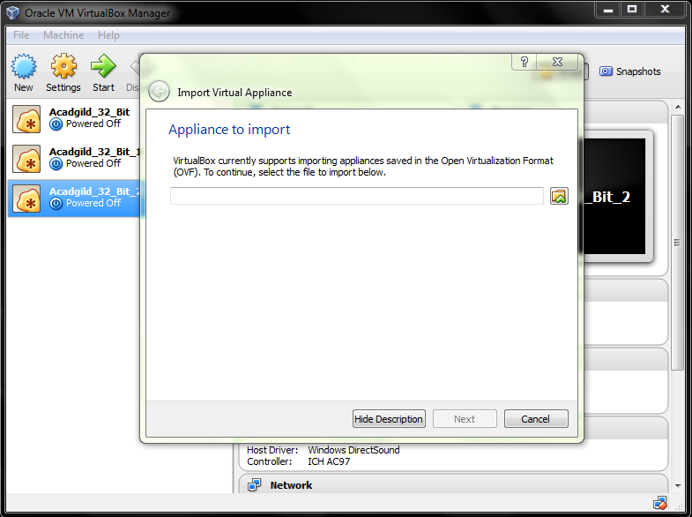

1. In the oracle virtual box go to File 🡪 import appliances then it will display the above window.
2. Now browse the acadgild in the browse tag.
3. After that click the next option it will install and the oracle virtual box window is shown like below.

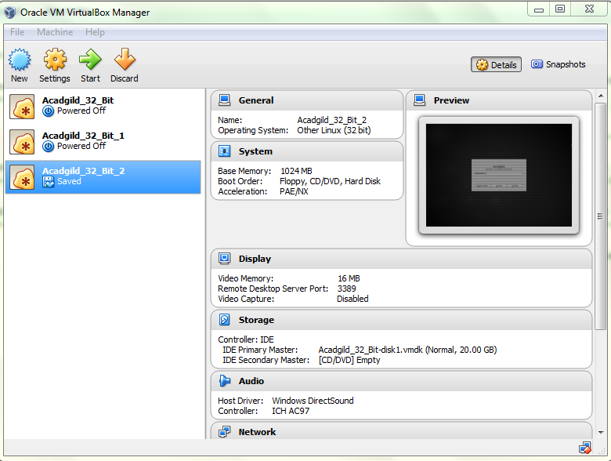

1. Click start to start the virtual machine.

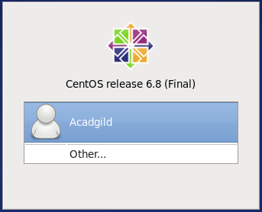

1. Login to the Acadgild then it will display the desktop as like below.

